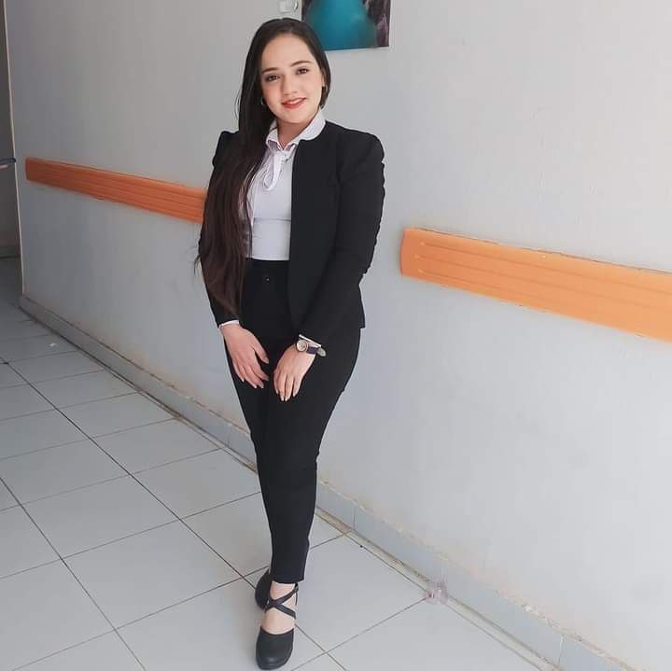

**Biography**

**Samia fathy kamel melk**

***Department of Pathology & Clinical Pathalogy Faculty of Veterinary Medicine Assuit University.***

**Personal Data :**

Name : Samia fathy kamel melk

Graduation Year : 2023

Study at : Faculty of Veterinary Medicine Assuit University.

Date of birth : 16\9\2000

Phone number : 01278403494

Address : Assuit \ Manfalut

E-mail : [samia1@.aun.edu.eg](mailto:samia1@.aun.edu.eg)

[samiamarina59@gmail.com](mailto:samiamarina59@gmail.com)

***# Working as: Demonstrator of Pathology department at Faculty of Veterinary Medicine Assuit***

***University.***

**# Teaching to undergraduate students >>>>> practical courses of general pathology, systemic pathology , special pathology & clinical pathology**

# Training & courses :

***Effective communication skills***

***The training program of credit hour system***

***The training course on publishing research in international journals***

***The training course*** ***Foundations of measurement, evaluation and ethics***